Associate Exit Flow

*(Associate Exit Flow – Guide)*

This document describes in detail the **Associate Exit Flow**. This portal has different user roles like (*Associate, HRM, HRA, Team Lead, IT department, Admin department, Finance department, Training department).*

1. **Associate:**
2. The associate is required to Login to the portal (Via single sign-on) with SenecaGlobal email Id. After authentication, the associate is redirected to the Dashboard page. The associate needs to click on the **Associate Exit** section, and then **Resignation module**.

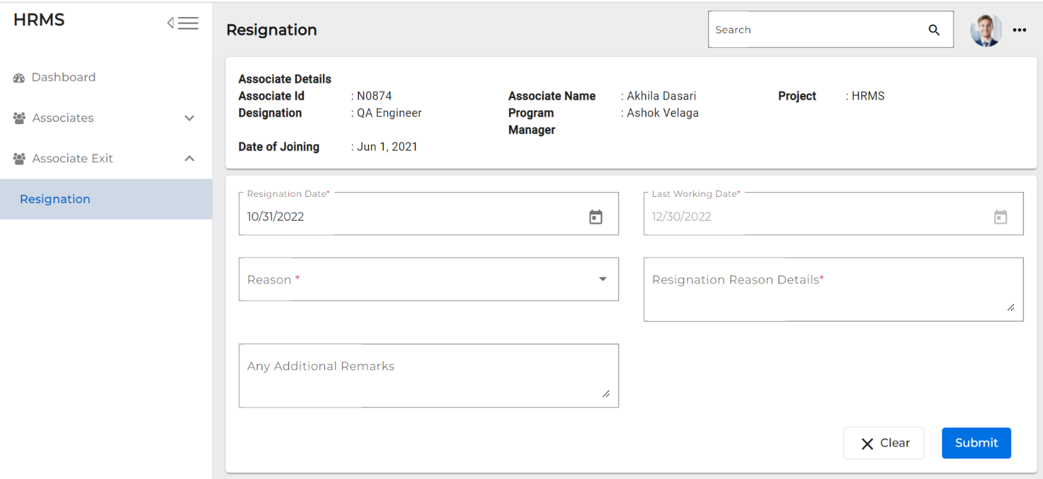

1. The ‘**Reason’** and ‘**Resignation Reason Detail’** fields are mandatory to be filled.
2. The associate needs to enter the resignation details and click on ‘**Submit’** button.

**V. The Team Lead, Program Manager and HRM leader are notified, and the status is changed to 'Resignation Submitted'.**

1. **Program Manager**
2. The Program Manager needs to Login into the portal (Via single sign-on) with SenecaGlobal email Id. After authentication, the associate is redirected to the Dashboard page. The associate needs to click on the **Associate Exit** section and then an **Exit-Action module**.
3. System will display below screen

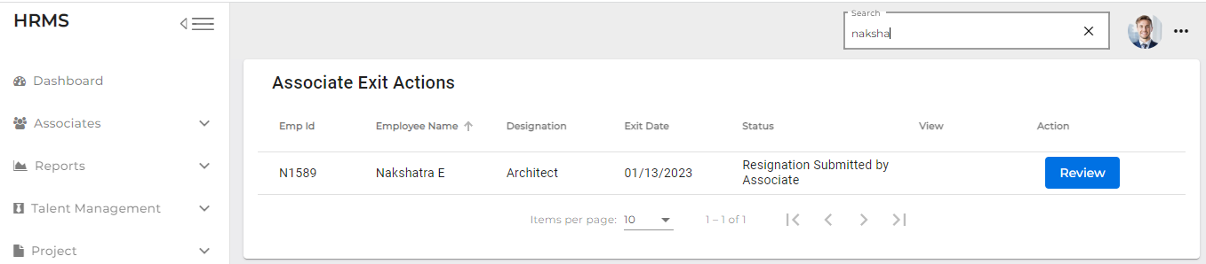

1. Status is shown as Resignation Submitted by Associate. PM will click on the Review button
2. System will display the below screen

1. By default, Client Impact and Eligible for Rehire radio buttons selected as "No" and PM can be able to change it
2. Clicking on submit button confirmation pop-up message will display as "Are you

Sure, you want to confirm with yes/no buttons”

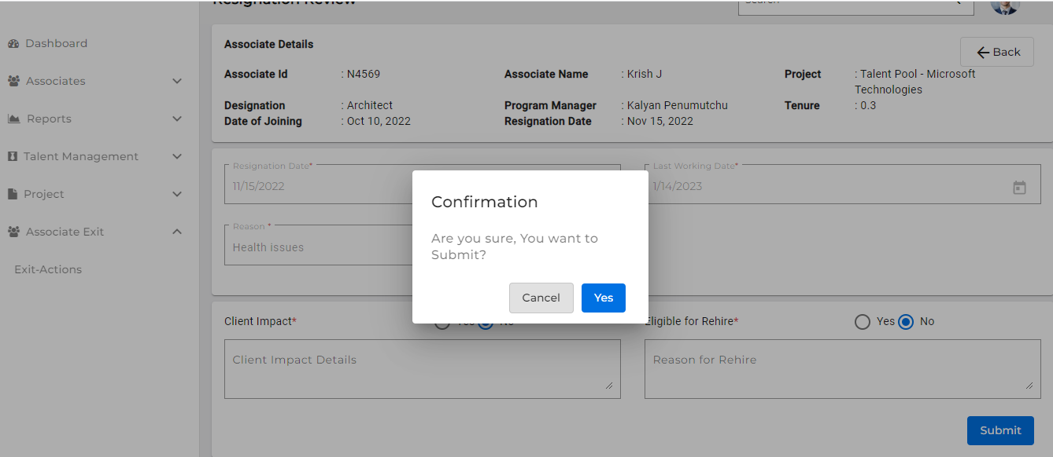

1. Click on Yes button toast message will display as “submitted successfully”
2. After submitting the Resignation Review by PM Exit Actions Review button should be in disabled mode, able to view (eye icon), and status is changed to "**Resignation Reviewed by PM**"
3. On the Associate dashboard status changes to “**Resignation Reviewed by PM.**”

**The Team Lead, Program Manager, Associate, and HRM leader are notified, and the status is changed to 'Resignation Submitted.'**

1. **HRM**

HRM leader needs to Login into the portal (Via single sign-on) with SenecaGlobal email Id. After authentication, HRM is redirected to the Dashboard page. HRM leader needs to click on the **Associate Exit** section and then an **Exit-Action** module.

1. System displays all the Resignation requests.

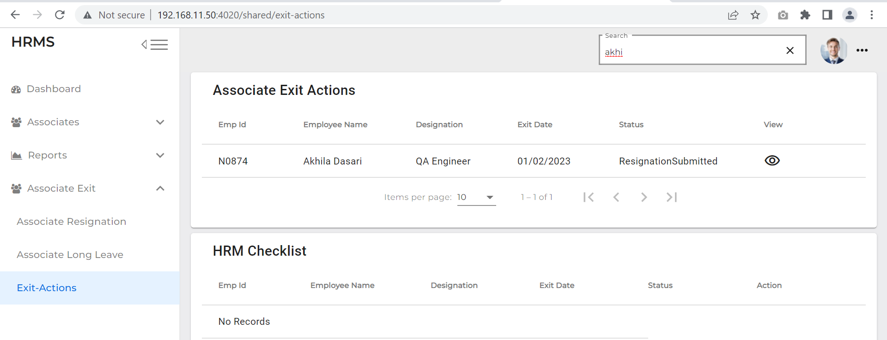

1. The HRM leader needs to select the relevant **‘Resignation submitted by PM**’ associate record
2. HRM clicks on Action button (right mark) (for accepting the resignation)
3. Clicking on view eye icon able to view the data in read-only mode.

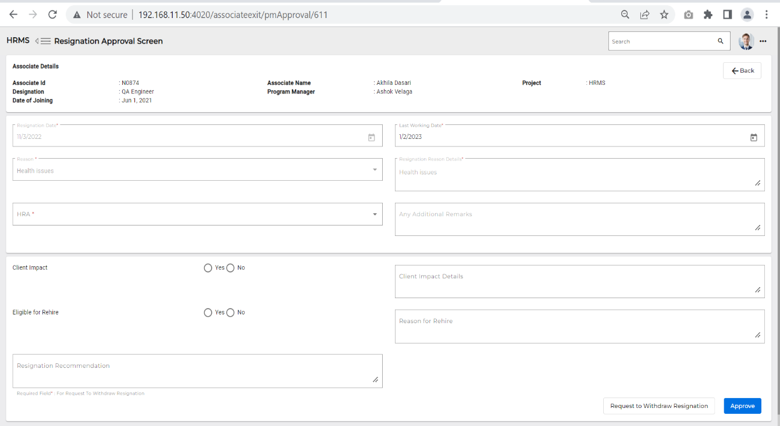

1. The System displays the below radio buttons with Yes/No, with disabled mode.

* Client Impact
* Eligible for Rehire
* **HRM clicks on Accept button email triggers to Team Lead, HRM, Associate** **PM, higher official, finance, HRA, and HR tag(Talent Acquisition). Then the status changes to “Resignation Accepted by HRM”**

1. **Associate**
2. Associate needs to login to the portal (Via single sign-on) with SenecaGlobal email Id. After authentication, associate will be redirected to the Dashboard page. Associate can view the revoke button.

1. The Associate can Revoke the resignation by giving suitable reason.
2. Click on Revoke
3. Give Revoke Reason
4. Click on Submit
5. After submitting the revoke on associate dashboard, revoke button becomes disabled and status changes to ‘**Revoke initiated.’**

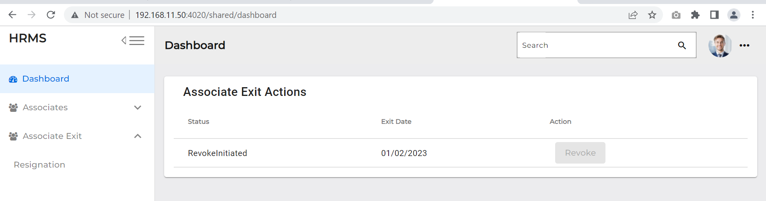

* **After submitting the Revoke, an Email is triggered to the Program manager, HRA, HRM and Associate; then the status is changed to ‘Revoke initiated.’**

1. **HRM**
2. HRM needs to login into the portal (Via single sign-on) with SenecaGlobal email Id. After authentication, HRM will be redirected to the Dashboard page. HRM needs to click on the **Associate Exit** section and an **Exit-Action** module.
3. HRM can view the associate who submitted **Revoke**, and the Status is changed to ‘**Revoke Initiated**.’
4. HRM needs to click on Actions button – ‘**Accept**’ (right mark).

* **When HRM Accepts, an Email is triggered to the Associate, Team lead, HRM and Program Manager then data will be removed from the HRM Exit actions**

1. HRM can Reject Resignation (cross mark) by giving the suitable reason and click on submit button then Revoke status is changes to “**Resignation Revoke Rejected by HRM**” and Exit flow will continue

1. **When Associate submits the resignation, and gets approval from HRM, the Team lead can start the KT plan, HRA can Initiate activities, and Exit interviews can proceed parallelly.**
2. **Able to view all the status which are done or in progress can view on Associate and HRM screens**
3. **Team Lead**
4. Team Lead needs to login to the portal (Via single sign-on) with SenecaGlobal email Id. After authentication, Team lead will be redirected to Dashboard page. In Team lead Dashboard, the Status of the associate who submitted the Resignation will be shown as ‘**Resignation In Progress.’**
5. 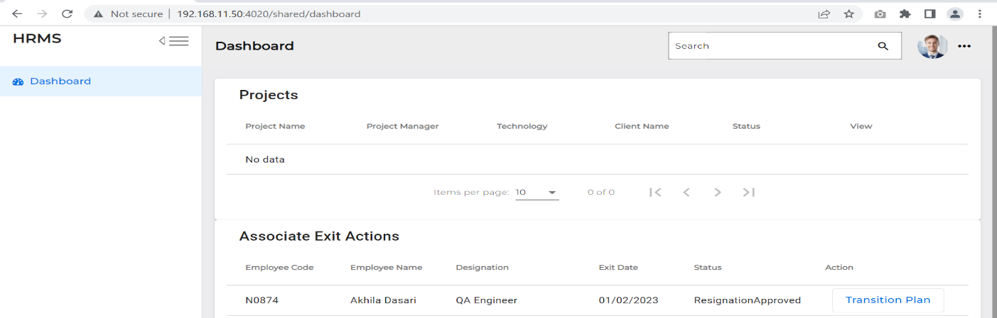Action Button Contains the Transition Plan.
6. 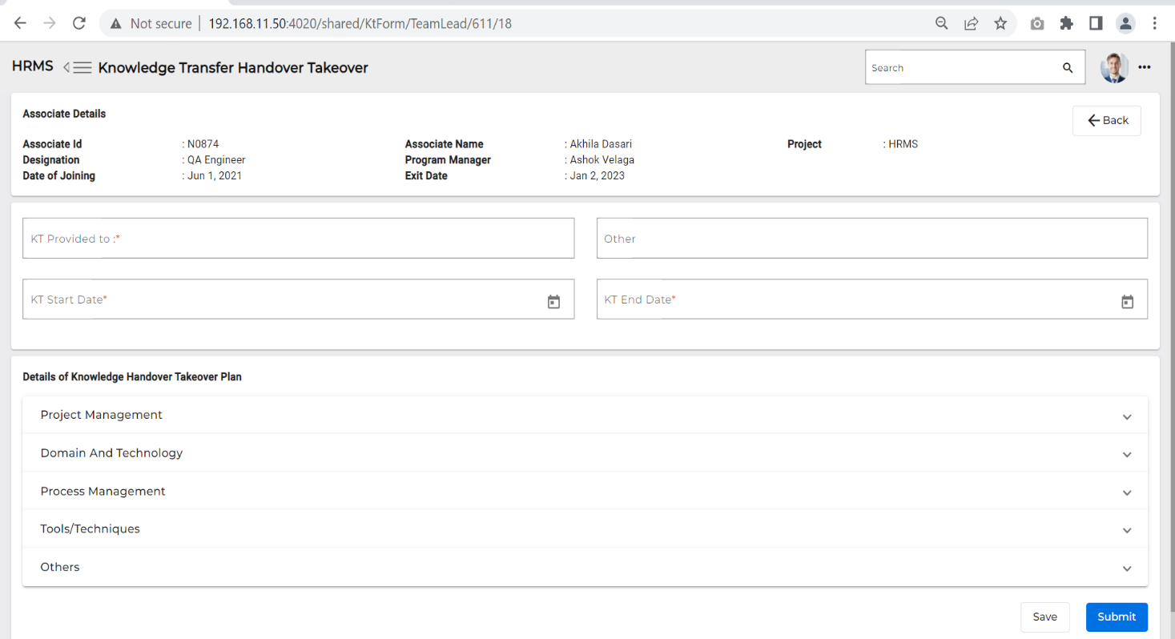If Team Lead clicks on **Transition plan** it is redirected to Knowledge Transfer Handover Takeover screen.
7. Team Lead needs to enter all the fields in the Knowledge Transfer Handover Takeover page, which is Mandatory.

* KT Start Date
* KT End Date
* KT Provided To
* Others (not mandatory field)
* Details of Knowledge handover takeover plan

1. If the team lead clicks on the save button, it is saved in the draft mode on **Team lead** only.
2. If Team Lead clicks on **Submit** button, ‘**KT plan’** is submitted to the Associate.

* **An email is triggered to the associate, and the status is changed to ‘KT plan in progress’**

1. **Associate**
2. Associate needs to login into the portal (Via single sign-on) with SenecaGlobal email Id. After authentication, associate will be redirected to the Dashboard page. Associate can now view the Transition plan button.

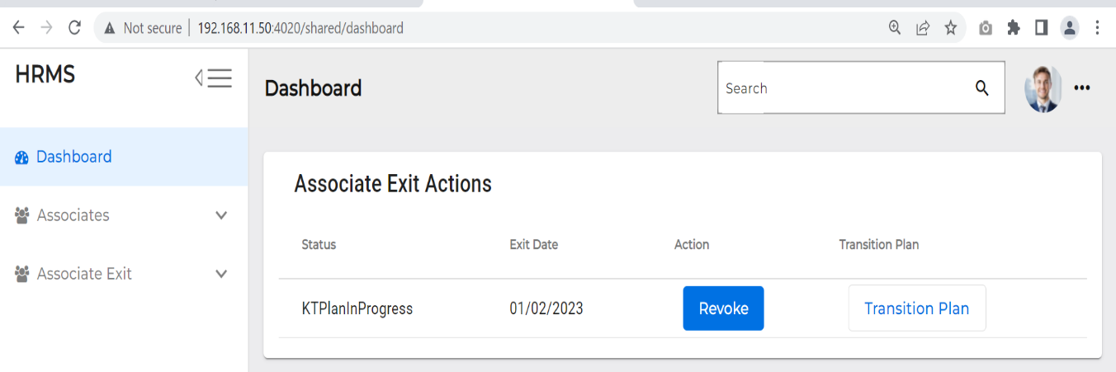

1. When the Transition plan button is clicked, it is redirected to the ‘Knowledge Transfer Handover Takeover’ screen.

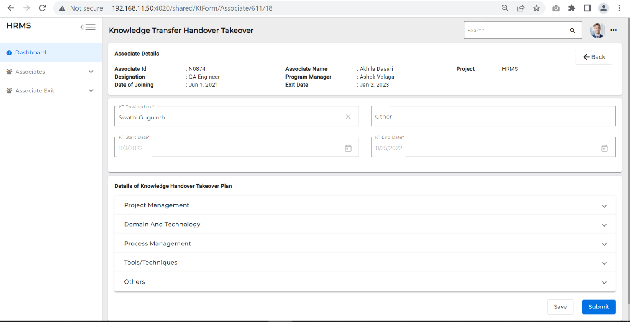

1. Other fields are ‘Read only’ mode, except – the Details of Knowledge handover Take cover plan status field.
2. System displays all the tasks that need to be completed before the last working date.
3. Associate should change the status as ‘Completed’ in the Knowledge handover Takeover Plan.
4. Clicking on ‘Submit’ changes the status to Resignation In Progress.

* **An Email is triggered to the Team Lead, the KT plan is submitted, and the status is changed to ‘Resignation In progress’**

1. **Team Lead**
2. Team Lead needs to login to the portal (Via single sign-on) with SenecaGlobal email Id. After authentication, Team Lead will be redirected to the Dashboard page. In the Team lead Dashboard, the status of the associate who submitted the KT plan changes to **‘KT plan Submitted.’**
3. If Associate KT plan’s status is ‘**KT plan submitted’** then the Team lead needs to click on the ‘**Transition plan’** button.

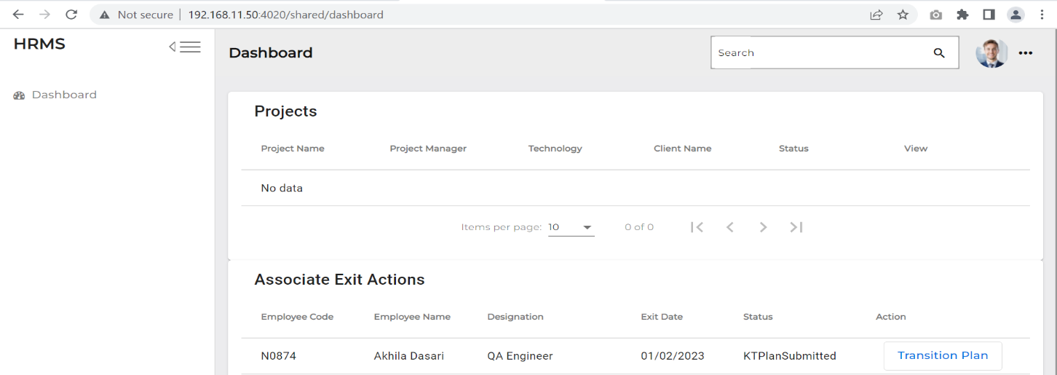

1. Once the Team Lead clicks the Transition plan button it is redirected to Knowledge Transfer Handover Takeover screen.

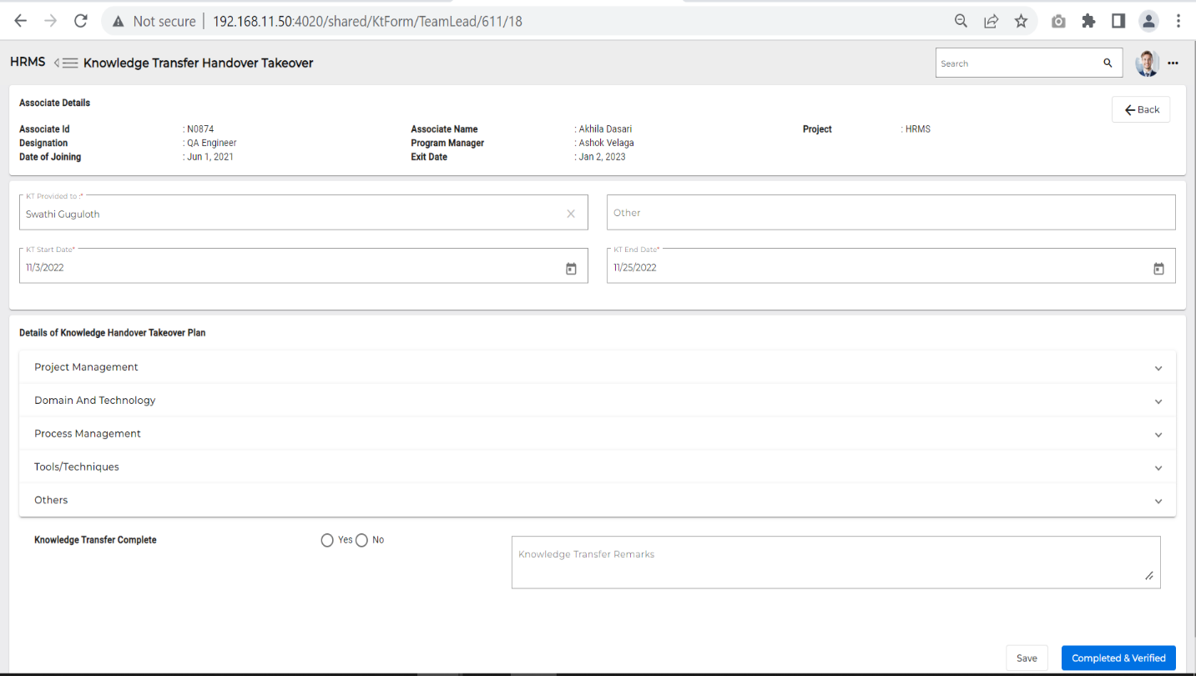

1. ‘**Knowledge Transfer complete’** has two radio buttons with Yes and No.
2. If Team lead clicks on ‘**Completed & verified’**, the associate’s record is removed from the Team Lead’s Dashboard Status changes to ‘Resignation in Progress’
3. Associate dashboard the status is changed to ‘**KT Plan completed’**.
4. **HRA**
5. HRA needs to Login into the portal (Via single sign-on) with SenecaGlobal email Id. After authentication,

HRA will be redirected to the Dashboard page. HRA needs to click on the Associate Exit section and an Exit-Action module.

1. **Can initiate the activities and Parallelly KT plan, Exit Interview actions can be done**
2. Can view the status is viewed as “Resignation In progress”
3. Once HRM Accept the resignation email will trigger to respective service departments
4. Click on Exit Clearance to view all the checklists with red colour (not yet submitted).

* **An Email is triggered to the respective service departments.**

1. HRA needs to click on Exit Clearance, to view all the checklist with red colour (not yet submitted).

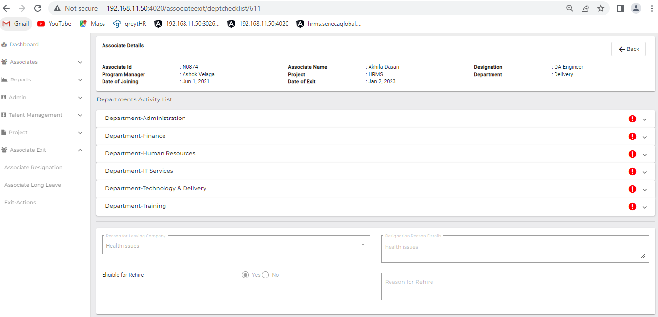

1. Department list

* Administration
* Finance
* Human Resource
* IT Services
* Training department

1. An email is triggered to all the above-mentioned Departments.
2. **IT Department**

1. IT Manager needs to Login into the portal (Via single sign-on) with SenecaGlobal email Id. After authentication, IT manager will be redirected to the Dashboard page. They need to click on the Associate Exit section and Exit-Action module to view '**Pending Request.'**

1. Now the System will display Associates details who are resigning with status as '**Resignation InProgress'** for IT Department.
2. Clicking on **Approve Checklist** Button navigates to Associate Exit Check List screen

* Below checklist activities need to be submitted:
* **Handover of Assets:**
* Desktop**/**Laptop
* Other devices (Tablet PC, iPhone, iPad…)
* Mobile phone
* Data card
* Headphones
* Client Hardware Assets
* Client Software Assets
* Removal of client VPN and any other access
* Backup of system, Data and email
* Others
* **Removal of Access, Privilege, Benefit:**
* Deactivation and Removal of active directory user credential
* Deactivate Jira and Removal of Bit Bucket/TFS
* Removal of Email access
* Removal of Conferencing account access
* Removal of Internet Access
* Others

1. Clicking on Save button saves it as a Draft.
2. **Once submitted, the clearance and IT Department will issue the NOC, and notifies the Associate and HRM Head, as the Status is updated to 'Completed'.**
3. Now the Particular Associate data is cleared from the IT Manager's screen.
4. **Admin Manager**
5. Admin Manager needs to Login into the portal (Via single sign-on) with SenecaGlobal email Id. After authentication, Admin manager will be redirected to the Dashboard page. They need to click on the Associate Exit section and Exit-Action module to view '**Pending Request.'**
6. The system will display the Associate details who are resigning with the status '**Resignation InProgress'** for Admin Department.
7. Clicking on ‘**Approve Checklist’** Button navigates to ‘**Associate Exit Check List’** screen.
8. Admin Department must submit below checklist activities

* **Handover of Assets:**
* Stationery items
* Desk/cabin keys
* Library books
* Associate ID card
* Others
* **Removal of Access, Privilege, Benefit:**
* Deactivation of office entry access card and biometric attendance entry
* Others

1. Clicking on Save button saves it as a draft.

* **If Admin issues NOC clearance, the Associate and HRM Leader are notified, and Status is updated to 'Completed'.**

1. The Associate data of the associate is cleared from the Admin Manager Screen.
2. **Finance Department**
3. Finance team needs to Login into the portal (Via single sign-on) with SenecaGlobal email Id. After authentication, team will be redirected to the Dashboard page. They need to click on the Associate Exit section and Exit-Action module to view '**Pending Request.'**
4. The system will display the Associate details who are resigning with status '**Resignation InProgress'** for Finance Department.
5. Clicking on ‘**Approve**’, Checklist Button navigates to the ‘**Associate Exit Check List’** screen.
6. Finance Department needs to submit below checklist activities:

* **Income Tax Compliance:**
* Submission of Income tax declaration documents for tax exemption
* Submission of SGBP proof documents for tax exemption
* Others
* **Amount to be Recovered from Associate:**
* Income Tax
* Travel advance
* Others

1. Clicking on Save button will save it as a draft.

* **When Finance Department issues the NOC, it is notified to the Associate and HRM Leader, and the Status is updated to ‘Completed’.**

1. The associate data is then cleared from the Finance Manager Screen.
2. **HRM (Human Resource)**
3. HRM needs to Login into the portal (Via single sign-on) with SenecaGlobal email Id. After authentication, HRM will be redirected to the Dashboard page. They need to click on the Associate Exit section and Exit-Action module to view 'Pending Request'.
4. The System will display Associate details who are resigning with status as ‘Resignation InProgress’ for HRM department.
5. Clicking on ‘Approve Checklist’ Button navigates to ‘Associate Exit Check List’ screen.
6. HR Department must submit the below checklist activities:

* **Handover of Assets:**
* Deactivation/Removal of access to Greytip
* Medical insurance
* Group gratuity
* Accident insurance
* Meal card/Multi wallet card
* Provident fund
* **Amount to be Recovered from Associate:**
* Notice Period Buyout Amount
* Relocation Expenses
* Joining Bonus
* Salary Advance
* Excess Salary Paid
* Others

1. Clicking on Save button saves it as a draft.

* **When HRM issues the NOC, the Associate and HRM HR Leader are notified, and the status is updated to ‘Completed’.**

1. The Particular Associate’s data is cleared from the HRM Screen.
2. **Training Department**
3. The training team needs to login to the portal (Via single sign-on) with SenecaGlobal email Id. After authentication, Training department will be redirected to the Dashboard page. They need to click on Associate Exit section and Exit-Action module to view ‘Pending Request’.
4. System will display Associate details of associates who are resigning with status as ‘**Resignation InProgress’** for Training Department.
5. Clicking on ‘**Approve**’ Checklist Button navigates to ‘**Associate Exit Check List’** screen.
6. Training department needs to submit the below checklist activities:

* **Handover of Assets:**
* Training kits
* Others
* **Removal of Access, Privilege, Benefit:**
* Access to training websites
* Others

1. Clicking on Save button saves it as a draft.

* **If Technology & Delivery Manager issues NOC clearance, the Associate and HRM Leader are notified, and Status is updated to ‘Completed’**

1. The Particular Associate data is cleared from the Training department Dashboard.
2. **Corporate**
3. Corporate needs to login to the portal (Via single sign-on) with SenecaGlobal email Id. After authentication, HRA will be redirected to the Dashboard page. They need to click on Associate Exit section and Exit-Action module to view “Pending Request”.
4. Once all the departments ‘Approve checklist’ is done, status is changed to ‘Resignation in Progress’ and can view ‘Exit interview’ button.
5. Click on ‘**Associate details’** having the status as ‘**Resignation In Progress’**
6. 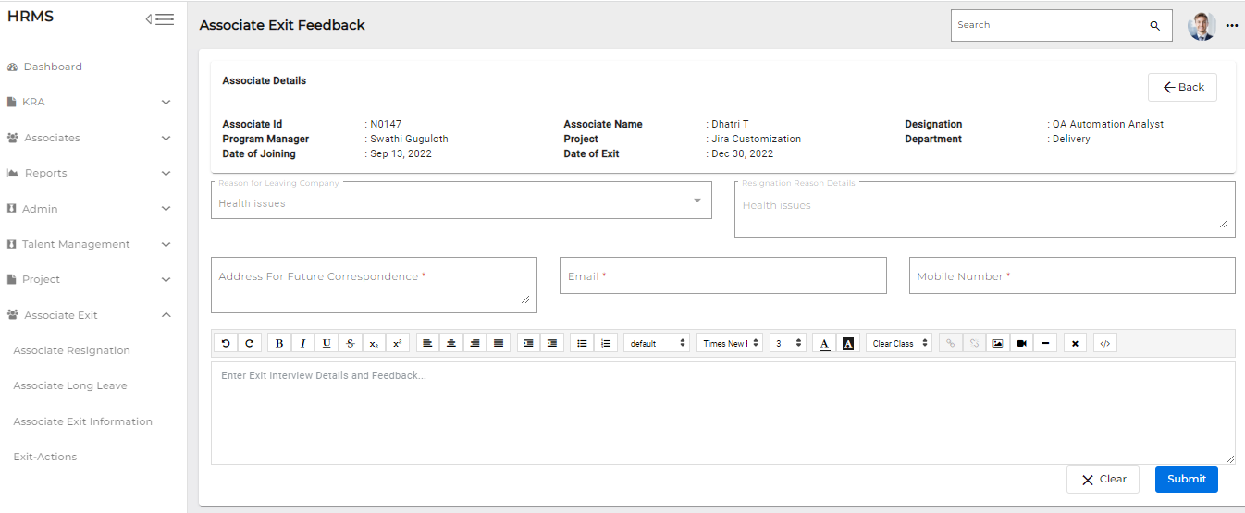Clicking on ‘**Exit Interview’** Button navigates to the ‘**Associate Exit Interview’** screen.
7. Corporate lead enters the associate address for future correspondence, email address and mobile number

* **Clicking on the submit button after Exit interview is done, Email triggers status changes status to ‘Exit interview completed’**

1. **HRM**
2. HRM needs to login to the portal (Via single sign-on) with SenecaGlobal email Id. After authentication, HRM will be redirected to the Dashboard page. They need to click on Associate Exit section and Exit-Action module.
3. Once all the department checklists and exit interview is done, HRM logs and gives the HR remarks.
4. Once the department can view all the checklist changed to green colour (Checklist completed), they can click on ‘Submit’ button.

* **If HRA Activities or KT plan or Exit interview any one of these actions is not completed, then Prompt message will display when HRM tries to submit the Exit clearance**

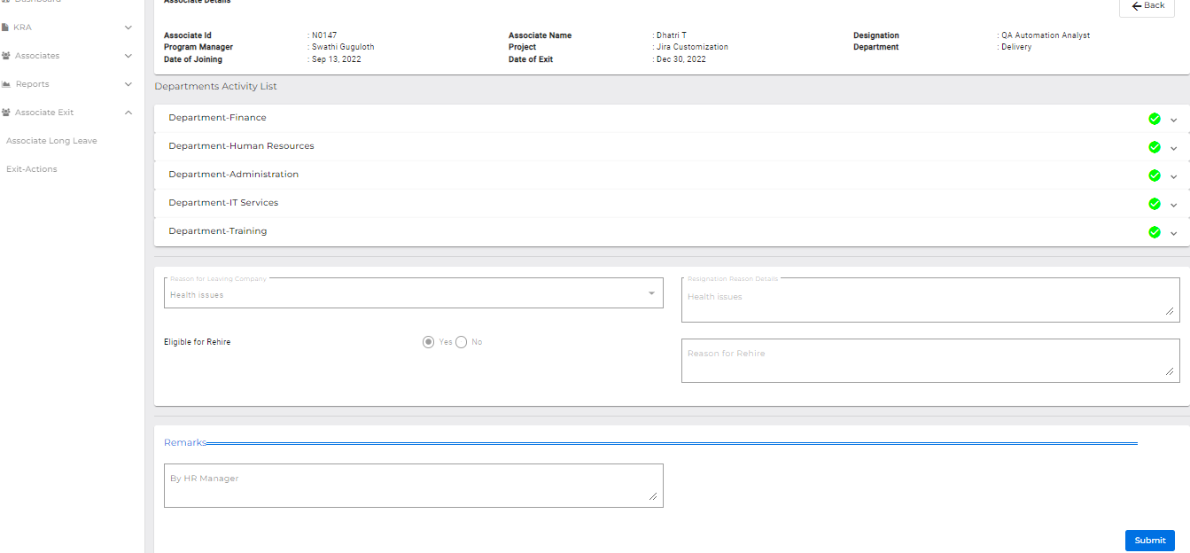

1. Associate data should be removed from the HRM
2. Associate Exit-Actions dashboard

* **Account will be deactivated from HRM application**
* **Status is changed to ‘Resigned’ and an is triggered to the HRM and departments heads.**
* **Till last working date associate data is available. On Associate and HRM dashboard we can check or track the status of associate till Final approval is given by HRM.**